KYMATOEIDH ΛΑΜΑΡΙΝΕΣ
CORRUGATED SHEETS

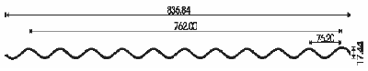

ΓΑΛΒΑΝΙΖΕ  GALVANIZED | ΚΑΘΑΡΗ ΚΑΛΥΨΗ  PURE COVERAGE | ΒΑΡΟΣ/m  WEIGHT/m
 | mm | kg
0.30 | 760 | 2.80
0.35 | 760 | 3.30
0.40 | 760 | 3.75
0.45 | 760 | 4.19
0.50 | 760 | 4.52

