ΣΤΡΟΓΓΥΛΑ – ΤΕΤΡΑΓΩΝΑ – ΠΟΛΥΓΩΝΑ
ROUNDS – SQUARES - HEXAGONAL
ΠΑΧΟΣ  THICKNESS | 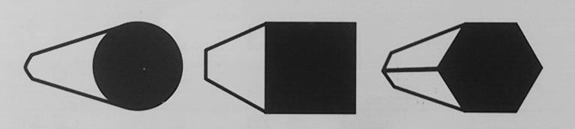 |  |  | ΠΑΧΟΣ  THICKNESS
mm | Kg/m | Kg/m | Kg/m
5 | 0.150 | 0.200 | 0.170 | 42 | 10.880 | 13.840 | 12.000
6 | 0.220 | 0.280 | 0.240 | 45 | 12.490 | 15.900 | -
8 | 0.400 | 0.500 | 0.440 | 50 | 15.410 | 19.630 | 17.000
10 | 0.620 | 0.790 | 0.680 | 55 | 18.650 | 23.750 | 20.600
12 | 0.890 | 1.130 | 0.980 | 60 | 22.200 | 28.260 | 24.470
14 | 1.210 | 1.540 | 1.330 | 65 | 26.050 | 33.150 | 28.800
15 | 1.390 | 1.770 | 1.530 | 70 | 30.210 | 38.470 | 33.310
16 | 1.580 | 2.010 | 1.750 | 75 | 34.680 | 44.160 | 38.250
18 | 2.000 | 2.540 | 2.200 | 80 | 39.460 | 50.240 | 43.510
20 | 2.470 | 3.140 | 2.720 | 85 | 44.550 | 56.720 | 49.120
22 | 2.980 | 3.800 | 3.290 | 90 | 49.940 | 63.590 | 55.070
24 | 3.550 | 4.530 | 3.910 | 95 | 55.640 | 70.990 | 61.360
25 | 3.850 | 4.910 | 4.250 | 100 | 61.650 | 78.500 | 67.980
26 | 4.170 | 5.300 | 4.600 | 110 | 74.600 | 95.000 | 82.400
28 | 4.830 | 6.150 | 5.330 | 115 | 81.540 | 104.000 | 89.910
30 | 5.550 | 7.070 | 6.120 | 120 | 88.780 | 113.000 | 97.900
32 | 6.310 | 8.040 | 6.960 | 125 | 96.330 | 123.000 | 106.220
35 | 7.750 | 9.620 | - | 130 | 104.200 | 133.000 | 114.890
38 | 8.900 | 11.340 | 9.810 | 140 | 120.840 | 154.000 | 133.000
40 | 9.870 | 12.560 | 10.880 | 150 | 138.720 | 177.000 | 152.960

