ΔΟΚΟΙ IPN
IPN BEAMS

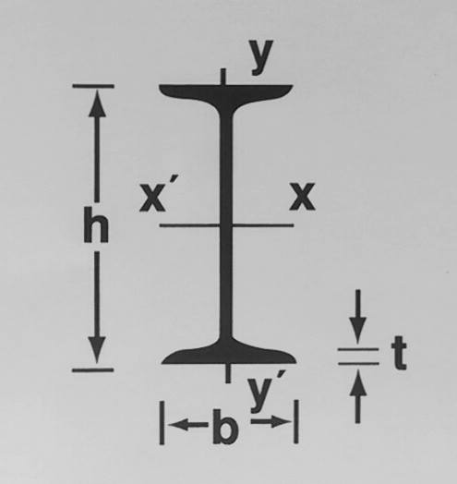
 | ΒΑΡΟΣ  WEIGHT  Kg/m | ΔΙΑΣΤΑΣΕΙΣ  DIMENSIONS  Mm |  |  |  | ΔΙΑΤΟΜΗ  SECTIONS  Cm2 | ΡΟΠΗ ΑΝΤΙΣΤΑΣΕΩΣ  MOMENT OF RESISTANCE  Cm3
 |  | h | b | s | t | F | Wx | Wy
IPN 80 | 5,940 | 80 | 42 | 3.9 | 5.9 | 7.57 | 19.5 | 3.00
IPN 100 | 8,340 | 100 | 50 | 4.5 | 6.8 | 10.60 | 34.2 | 4.88
IPN 120 | 11,100 | 120 | 58 | 5.1 | 7.7 | 14.20 | 54.7 | 7.41
IPN 140 | 14,300 | 140 | 66 | 5.7 | 8.6 | 18.20 | 81.9 | 10.70
IPN 160 | 17,900 | 160 | 74 | 6.3 | 9.5 | 22.80 | 117.0 | 14.80
IPN 180 | 21,900 | 180 | 82 | 6.9 | 10.4 | 27.90 | 161.0 | 19.80
IPN 200 | 26,200 | 200 | 90 | 7.5 | 11.3 | 33.40 | 214.0 | 26.00
IPN 220 | 31,100 | 220 | 98 | 8.1 | 12.2 | 39.50 | 278.0 | 33.10
IPN 240 | 36,200 | 240 | 106 | 8.7 | 13.1 | 46.10 | 354.0 | 41.70
IPN 260 | 41,900 | 260 | 113 | 9.4 | 14.1 | 53.30 | 442.0 | 54.00
IPN 280 | 47,900 | 280 | 119 | 10.1 | 15.2 | 61.00 | 542.0 | 61.20
IPN 300 | 54,200 | 300 | 125 | 10.8 | 16.2 | 69.00 | 653.0 | 72.20
IPN 320 | 61,000 | 320 | 131 | 11.5 | 17.3 | 77.70 | 782.0 | 84.70
IPN 340 | 68,000 | 340 | 137 | 12.2 | 18.3 | 86.70 | 923.0 | 98.40
IPN 360 | 76,100 | 360 | 143 | 13.0 | 19.5 | 97.00 | 1090.0 | 114.00
IPN 400 | 92,400 | 400 | 155 | 14.4 | 21.6 | 118.00 | 1460.0 | 149.00
IPN 450 | 115,000 | 450 | 170 | 16.2 | 24.3 | 147.00 | 2040.0 | 203.00
IPN 500 | 141,000 | 500 | 185 | 18.0 | 27.0 | 179.00 | 2750.0 | 268.00
IPN 550 | 166,000 | 550 | 200 | 19.0 | 30.0 | 212.00 | 3610.0 | 349.00

