ΓΑΛΒΑΝΙΖΕ ΛΑΜΑΡΙΝΕΣ
GALVANIZED SHEETS AND COILS

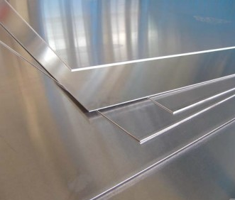

ΠΑΧΟΣ  THICKNESS | ΘΕΩΡΙΤΙΚΑ ΒΑΡΗ  THEORETICAL WEIGHT
mm | 1000 × 2000 (mm) | 1250 × 2500 (mm) | 1500 × 3000 (mm)
0.25 | 3.93 | 6.13 | -
0.30 | 4.71 | 7.36 | -
0.40 | 6.28 | 9.81 | -
0.50 | 7.85 | 12.27 | -
0.60 | 9.42 | 14.72 | -
0.70 | 10.99 | 17.17 | -
0.80 | 12.56 | 19.63 | 28.26
0.90 | 14.13 | 22.08 | 31.78
1.00 | 15.70 | 24.53 | 35.33
1.25 | 19.62 | 30.66 | 44.15
1.50 | 23.56 | 36.81 | 53.01
2.00 | 31.40 | 49.06 | 70.65
2.50 | 39.24 | 67.31 | 88.29
3.00 | 47.10 | 73.59 | 105.98
4.00 | 62.80 | 98.13 | 141.30

