ΛΑΜΑΡΙΝΕΣ ΜΠΑΚΛΑΒΩΤΕΣ ΚΑΙ ΚΡΙΘΑΡΩΤΕΣ
HOT ROLLED CHEQUERED SHEETS AND COILS

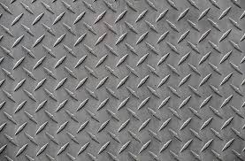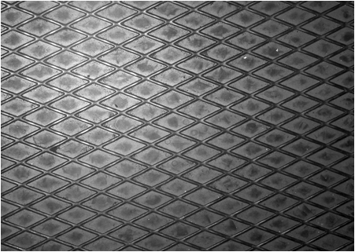

ΠΑΧΟΣ  THICKNESS | ΘΕΩΡΙΤΙΚΑ ΒΑΡΗ  THEORETICAL WEIGHT
mm | 1000 × 2000 |  | 1250 × 2500 |  | 1500 × 3000
 | ΜΠΑΚΛΑΒΟΤΕΣ | ΚΡΙΘΑΡΩΤΕΣ | ΜΠΑΚΛΑΒΟΤΕΣ | ΚΡΙΘΑΡΩΤΕΣ | ΜΠΑΚΛΑΒΟΤΕΣ | ΚΡΙΘΑΡΩΤΕΣ
2.00 | 35.40 | - | 55.31 | - | 79.65 | -
2.50 | 43.26 | 47.26 | 67.59 | 73.84 | 97.33 | 106.34
3.00 | 51.10 | 55.10 | 79.84 | 86.09 | 114.97 | 123.98
4.00 | 66.80 | 70.80 | 104.38 | 110.63 | 150.31 | 159.30
5.00 | 82.50 | 86.50 | 128.91 | 135.16 | 185.63 | 194.63
6.00 | 98.20 | 102.20 | 153.44 | 159.69 | 220.95 | 229.95
8.00 | 129.60 | 133.60 | 202.50 | 208.75 | 291.60 | 300.60
10.00 | 181.00 | 185.00 | 282.81 | 289.06 | 407.25 | 416.25

